

DEPARTMENT OF CSE(DATA SCIENCE)
DBMS MINI Project Report (BCS403)
On

DEPT. EDU EQUIPMENT INVENTORY MANAGEMENT SYSTEM

Submitted by

SHREYAS S A

4PM22CD047

MARKS AWARDED
Presentation(5M) | Report (5M) | Total (10M) | Faculty Sign with Date

COORDINATER HOD
Mrs.Sheethal Lobo Dr.Sunitha B S

………………… ………………………

TABLE OF CONTENTS
Cover Page (i)
Certificate (ii)
Abstract (iii)
Chapter No. Chapter Description Page No.

CHAPTER-1 INTRODUCTION 1
1.1 OVERVIEW OF DEPED EQUIPMENT INVENTORY MANAGEMENT SYSTEM 1
1.2 OBJECTIVES 2
1.3 About DBMS 3
1.4 About RDBMS 3

CHAPTER-2 SYSTEM REQUIREMENTS SPECIFICATION 4
2.1 Software Requirements 4
2.2 Hardware Requirements 4
2.3 Technologies used 4
2.4. About tool used 5

2.5 About Programming Language 5

CHAPTER 3 SYSTEM DESIGN 6
3.1 Schema Diagram for DepEd Equipment Management 6
3.2 E-R Diagram For DepEd Equipment Management 7

CHAPTER 4 SYSTEM IMPLEMENTATION 8
4.1 Modules 9
CHAPTER 5 SNAPSHOTS AND RESULTS 10
5.1 Login Page 10
5.2 Dashboard 10
5.3 Request Information 11
5.4 DepEd equipment Report 11
CHAPTER 6 CONCLUSION 12

CERTIFICATE

This is to certify that the “DBMS Mini Project on DepEd Equipment inventory management system” activity is a bonafide work carried out by SHREYAS (4PM22CD047), submitted in the partial fulfilment for IV Semester Examination of Bachelor of Engineering Department of Computer Science and Engineering (Data Science) of the Visvesvaraya Technological University, Belagavi, during the academic year 2023-2024. It is certified that all corrections/suggestions indicated for Assessment have been incorporated in the report. The activity has been approved as it satisfies the academic requirements in respect of the “Database Management System (BCS403)”, activity work prescribed for the said degree.

Guide:

…………………….. ……………………
Mrs. Sheethal Lobo Dr. Sunitha B S
Assistant Professor HOD
CSE (Data Science) CSE(Data Science)

ABSTRACT
Managing equipment inventory within educational departments poses significant challenges due to the diverse nature of educational assets and the need for efficient utilization and maintenance. Traditional methods often involve manual record-keeping and limited visibility, leading to inefficiencies and errors in inventory management. To address these issues, this study proposes the development of a Department of Education Equipment Inventory Management System (DEEIMS).
DEEIMS aims to streamline the management of educational equipment by providing a centralized, automated platform for tracking, monitoring, and maintaining inventory data. The system leverages modern technologies such as RFID tagging, barcode scanning, and cloud-based databases to enhance accuracy, accessibility, and real-time visibility of equipment status.
Key functionalities of DEEIMS include asset registration, categorization, location tracking, maintenance scheduling, and reporting. By implementing DEEIMS, educational departments can improve operational efficiency, reduce administrative burden, optimize resource allocation, and ensure compliance with regulatory requirements.
This paper discusses the conceptual framework, system architecture, and implementation strategies for DEEIMS, emphasizing its potential benefits in enhancing equipment management practices within educational settings.
This abstract outlines the purpose, scope, and potential benefits of the proposed system without delving into specific technical details or outcomes. Adjustments can be made based on the specific focus or requirements of the actual DEEIMS being developed.

CHAPTER-1
INTRODUCTION

1.1 OVERVIEW OF DEPED EQUIPMENT MANAGEMENT SYSTEM:
The DepEd Equipment Management System is a comprehensive solution aimed at optimizing the management of educational resources across schools under the Department of Education. At its core, the system centralizes the tracking, monitoring, and maintenance of various types of educational equipment, ranging from classroom tools to specialized technology and infrastructure.
Key features include a centralized database that stores detailed information about each piece of equipment, such as type, model, acquisition date, location, and current status (e.g., in use, under repair, retired). This database enables real-time monitoring of equipment movement between schools and facilitates efficient allocation and utilization planning.
The system incorporates maintenance scheduling functionality to ensure timely servicing and repairs, thereby extending the lifespan of equipment and reducing downtime. It also includes a user-friendly interface that allows authorized personnel, such as school administrators and maintenance staff, to easily input data, retrieve information, and generate reports on equipment usage, maintenance history, and budget allocation.
By implementing the DepEd Equipment Management System, the department aims to enhance accountability in resource management, optimize operational efficiency, and improve the overall learning environment for students. The system's ability to provide comprehensive insights through analytics and reporting empowers decision-makers to make informed choices regarding equipment investments and allocations across the educational landscape.
In summary, the DepEd Equipment Management System represents a strategic initiative to modernize and streamline equipment management practices within the Department of Education, ultimately supporting its mission to deliver quality education through effective resource utilization.

1.2 OBJECTIVES:
- Centralized Inventory Management: Maintain a centralized database of all educational equipment, including details such as equipment type, model, serial number, acquisition date, location, and status (e.g., in use, under repair, retired).
- Tracking and Monitoring: Enable real-time tracking and monitoring of equipment movement within and between schools. Utilize barcode or RFID technology for efficient scanning and identification.
- Maintenance Scheduling: Facilitate proactive maintenance by scheduling regular inspections, repairs, and servicing of equipment based on predefined maintenance schedules and usage patterns.
- User Roles and Permissions: Implement role-based access control to ensure data security and restrict access to sensitive information based on user roles (e.g., administrators, school principals, maintenance staff).
- Reporting and Analytics: Generate comprehensive reports and analytics on equipment utilization, maintenance history, depreciation, and budget forecasting to support informed decision-making and resource allocation.
System Components
- Database: Utilize a relational database management system (e.g., MySQL, PostgreSQL) to store and manage equipment data securely.
- User Interface: Develop an intuitive web-based or desktop application interface for easy data entry, retrieval, and management.
- Barcode/RFID Integration: Integrate barcode or RFID technology for efficient equipment identification and tracking.
- Maintenance Scheduler: Implement a scheduler module to automate maintenance tasks and notifications.
- Reporting Module: Design a module for generating customizable reports and analytics to meet the diverse needs of stakeholders.
Implementation Strategy:
- Requirements Gathering: Conduct thorough requirements analysis to understand user needs, system functionalities, and integration requirements.
- Database Design: Design an efficient database schema to store equipment details, user information, audit logs, and configuration settings.

1.3 ABOUT DBMS
A Database Management System (DBMS) is a software application that enables users to efficiently organize, manipulate, and retrieve data stored in a database. Acting as an intermediary between the user and the database, DBMS provides tools for creating, modifying, and querying data in a structured manner. It ensures data integrity by enforcing constraints and security measures, allowing only authorized users to access and modify the data., DBMS ensures that multiple users can interact with the database simultaneously without compromising data consistency. Additionally, DBMS offers scalability, performance optimization, and backup/recovery mechanisms to handle large volumes of data and ensure its availability and durability. Overall, DBMS plays a crucial role in modern information systems, serving as a reliable and efficient solution for managing and leveraging data assets across diverse applications and industries. Database Management Systems (DBMS) are software systems used to store, retrieve, and run queries on data.

1.4 ABOUT RDBMS
A Relational Database Management System (RDBMS) is a specialized type of Database Management System (DBMS) that is based on the relational model of data organization. In an RDBMS, data is structured into tables, where each table consists of rows and columns, with each row representing a unique record and each column representing a specific attribute of the data. The strength of an RDBMS lies in its ability to establish relationships between different tables through keys, such as primary keys and foreign keys, enabling the creation of complex relational databases. RDBMSs provide mechanisms for enforcing data integrity, ensuring that the relationships between data elements remain consistent and accurate. Popular RDBMSs, such as MySQL, PostgreSQL, Oracle Database, and Microsoft SQL Server, offer robust features including support for transactions, concurrency control, indexing, and query optimization, making them essential tools for managing structured data in a wide range of applications, from enterprise systems to web applications and beyond.

CHAPTER 2
SYSTEM REQUIREMENTS SPECIFICATION

2.1 Software Requirements
- XAMPP
- Windows 11

2.2 Hardware Requirements
- Hard Disk – 2 GB.
- RAM – 1 GB.
- Processor – Dual Core or Above.
- Mouse.
- Keyboard.
- Monitor.
- Printer.

2.3 Technologies used
- HTML
- CSS
- JScript
- PHP
- MySQL
- Bootstrap

2.4. About tool used

2.4.1 XAMPP

XAMPP is an abbreviation where X stands for Cross-Platform, A stands for Apache, M stands for MYSQL, and the Ps stand for PHP and Perl, respectively. It is an open-source package of web solutions that includes Apache distribution for many servers and command- line executables along with modules such as Apache server, MariaDB, PHP, and Perl. XAMPP helps a local host or server to test its website and clients via computers and laptops before releasing it to the main server.

2.5 About Programming Language

2.5.1 PHP

PHP stands for Hypertext Preprocessor. It is an open-source, interpreted, and object-oriented scripting language that can be executed at the server-side. PHP is well suited for web development. Therefore, it is used to develop web applications (an application that executes on the server and generates the dynamic page. PHP was created by Rasmus Lerdorf in 1994 but appeared in the market in 1995.
PHP code may be embedded into HTML code, or it can be used in combination with various web template systems, web content management systems and web frameworks. PHP code is usually processed by a PHP interpreter implemented as a module in the web server or as a Common Gateway (CGI) executable. The web server combines the results of the generated web page.

2.5.2 JavaScript

JavaScript is the most popular scripting language for the Web. It is easy to learn, lightweight, crossplatform, single-threaded, and interpreted compiled language. It is widely used for web development, both on the client side and server side. As a scripting language, it plays an important role in web browsers, allowing real-time modification of web page content and enhancing user experience.

2.5.3 BOOTSTRAP

Bootstrap is a huge collection of reusable pieces of code which can be quite handy to the developers. It is a Frontend-Development Framework, written in HTML, CSS, and JavaScript. Bootstrap enables designers and developers to build completely responsive websites quickly. It can be considered the most popular CSS framework for developing responsive and Mobile- First applications. The main features of Bootstrap may be described as follows:
- Bootstrap provides the users with the ability to easily create responsive designs.
CHAPTER 3

SYSTEM DESIGN

3.1 Schema Diagram for DepEd Equipment Management
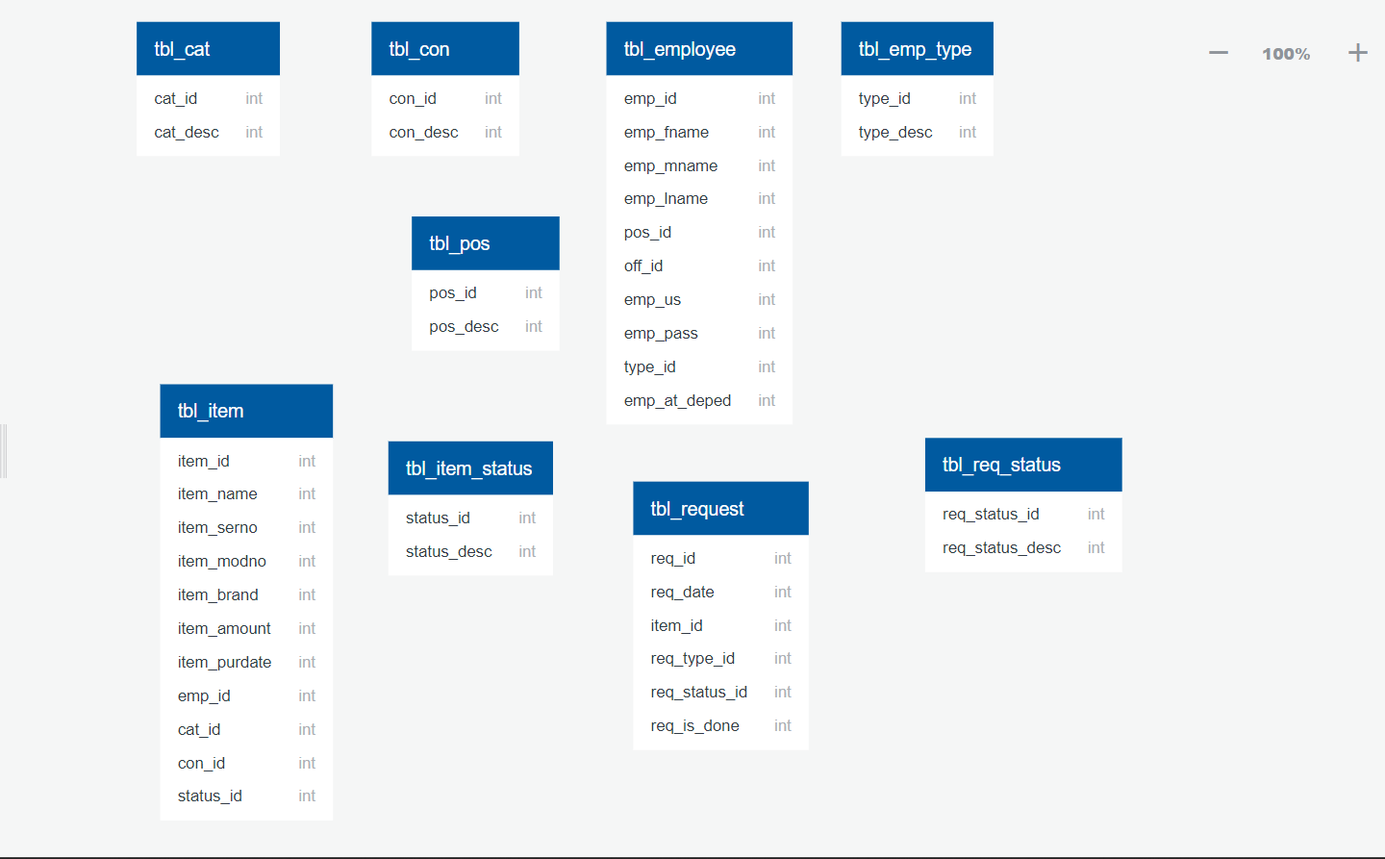

3.1 Schema Diagram for DepEd Equipment Management

3.2 E-R diagram For DepEd Equipment Management 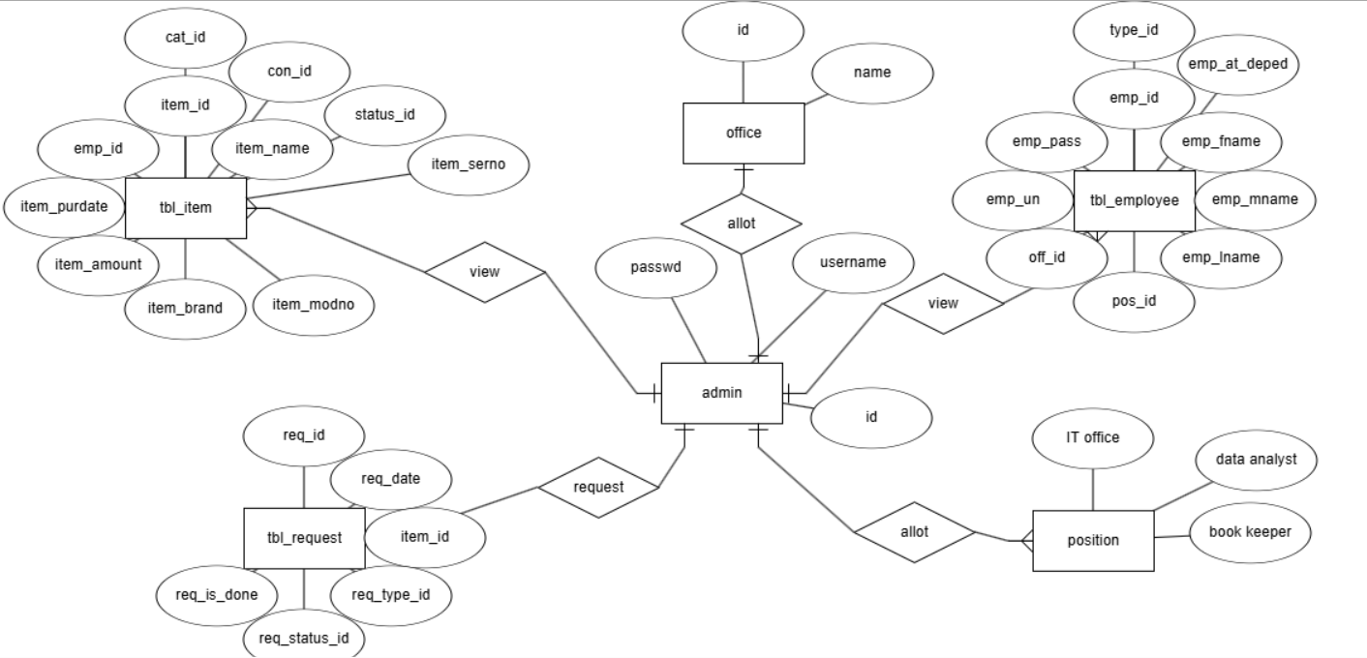
Fig 3.2 ER diagram for DepEd Equipment Management
For a DepEd (Department of Education) Equipment Inventory Management System, the ER diagram would typically include the following key entities and relationships:

Entities:
- Equipment
  - Attributes: EquipmentID, Name, Type, Brand, Model, PurchaseDate, WarrantyPeriod, Condition, Location, Status
- Department
  - Attributes: DepartmentID, Name, Location, HeadOfDepartment
- Employee
  - Attributes:EmployeeID, FirstName, LastName, Position, DepartmentID, ContactInformation
- InventoryTransaction
  - Attributes: TransactionID, EquipmentID, EmployeeID, DepartmentID, Date, Type (Issued/Returned), Remarks
- Supplier
  - Attributes: SupplierID, Name, ContactInformation, Address
- PurchaseOrder
  - Attributes: PurchaseOrderID, SupplierID, Date, TotalAmount
- PurchaseOrderDetails
  - Attributes: PurchaseOrderID, EquipmentID, Quantity, UnitPrice, TotalPrice

Relationships:
- Department - Employee: One-to-Many
- One department has many employees.
- Represented by DepartmentID in the Employee entity.
- Equipment - InventoryTransaction: One-to-Many
- One equipment item can have many inventory transactions (issued/returned).
- Represented by EquipmentID in the InventoryTransaction entity.
- Employee - InventoryTransaction: One-to-Many
- One employee can have many inventory transactions.
- Represented by EmployeeID in the InventoryTransaction entity.
- Department - InventoryTransaction: One-to-Many
- One department can have many inventory transactions.
- Represented by DepartmentID in the InventoryTransaction entity.

- Supplier - PurchaseOrder: One-to-Many
- One supplier can have many purchase orders.
- Represented by SupplierID in the PurchaseOrder entity.
- PurchaseOrder - PurchaseOrderDetails: One-to-Many
- One purchase order can have many purchase order details.
- Represented by PurchaseOrderID in the PurchaseOrderDetails entity.
- Equipment - PurchaseOrderDetails: One-to-Many
- One equipment item can be included in many purchase order details.
- Represented by EquipmentID in the PurchaseOrderDetails entity.

CHAPTER 4

SYSTEM IMPLEMENTATION

Implementation is the stage in the project where the theoretical design is turned into the working system and is giving confidence to the new system for the users i.e. it will work effectively. It involves careful planning, investigation of the current system and its constraints on implementation, design of method to achieve the changeover, an evaluation, of change over methods.

- Data Setup: Setting up a database in MySQL involves defining the structure of your data using tables, columns, and relationships. You begin by creating a database where all your data will be stored. Within this database, you define tables to represent different entities or concepts, such as users, products, orders, etc. Each table consists of columns that define the attributes of those entities, like names, IDs, dates, and so on.
- Backend Development: PHP's versatility and ease of integration with databases and web servers make it a popular choice for backend development, particularly in web application development. By mastering PHP fundamentals and best practices, you can create robust and scalable backend solutions to support various web applications.
- Front End Development: Front-end development involves crafting the user interface (UI) and experience (UX) of websites or web applications using HTML, CSS, and JavaScript. HTML forms the structure and content of web pages, using semantic tags to define the meaning of content for better accessibility and SEO. CSS styles these elements, controlling their appearance, layout, and responsiveness across different devices. JavaScript adds interactivity, enabling dynamic behavior like user input handling, DOM manipulation, and asynchronous communication with servers for data fetching and updating content without page reloads. Together, these technologies empower developers to create engaging and functional web experiences that cater to diverse user needs and preferences
- Integration and Testing: integrate your backend and frontend effectively. Utilize
XAMPP to set up a local development environment for testing. This allows you to seamlessly test functionalities like event registration, coordinator assignments, and data updates. Design test cases covering various scenarios and conduct usability testing to ensure a smooth user experience. Throughout development, document your code, database schema, and system architecture for future maintenance. Finally, gather user feedback and iterate on the system to continuously improve functionality and usability. This approach ensures a well-integrated, user-friendly system built for future success.

4.1 Modules:

An expense management system in a database management system (DBMS) typically consists of several core modules:
An equipment inventory management system for a Department of Education (DepEd) in a Database Management System (DBMS) typically consists of several core modules, each serving specific functions to manage and track equipment effectively. Here are the core modules that are commonly included:
- User Management Module:
  - Features: User authentication, role-based access control, user profiles, and activity logs.
  - Purpose: To manage who can access the system and what operations they can perform.
- Equipment Catalog Module:
  - Features: Equipment listing, detailed equipment specifications, categorization, and search functionality.
  - Purpose: To maintain a comprehensive database of all equipment available.
- Procurement Module:

  - Features: Maintenance schedules, repair requests, service history, and parts inventory.
  - Purpose: To ensure equipment is properly maintained and repaired when necessary.
4. Maintenance and Repair Module:
  - Features: Maintenance schedules, repair requests, service history, and parts inventory.
  - Purpose: To ensure equipment is properly maintained and repaired when necessary.
5.Reporting and Analytics Module:
  - Features: Customizable reports, inventory analytics, usage statistics, and
  - financial reports.
  - Purpose: To provide insights and data-driven decision-making tools.

CHAPTER 5

SNAPSHOTS AND RESULTS

5.1 Login Page:
The login page for the DepEd (Department of Education) Equipment Inventory Management System provides a secure gateway for authorized users to access and manage the inventory of educational equipment. This page is designed with a user-friendly interface, ensuring that users can easily log in to the system.
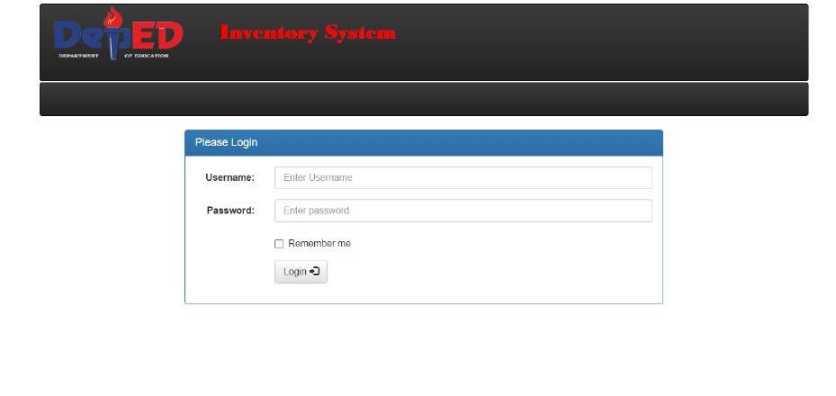

5.2 Dashboard:
The DepEd Equipment Inventory Management System (EIMS) dashboard is a centralized platform designed to manage and monitor the inventory of equipment within the Department of Education (DepEd). Here are its key features:

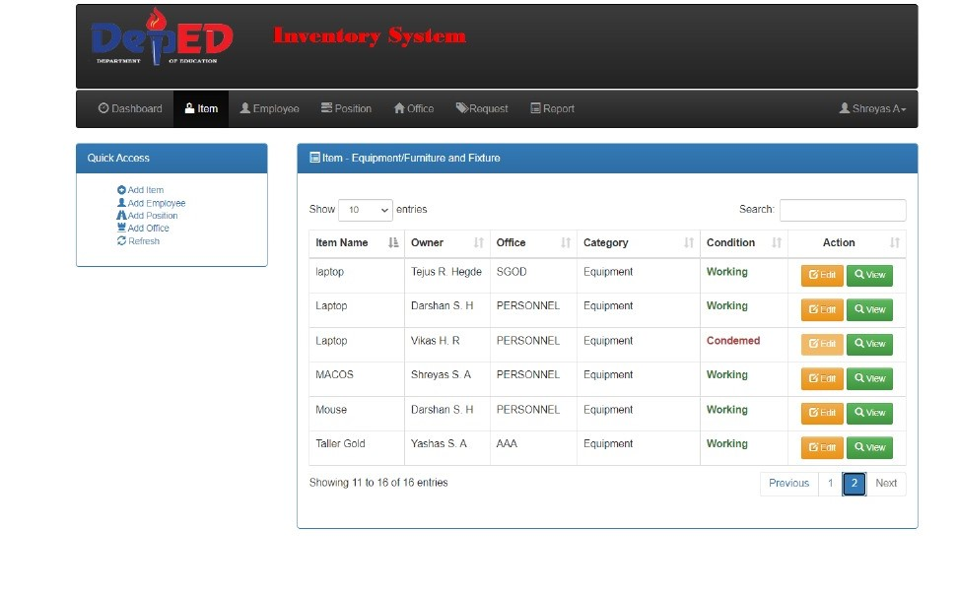
Fig 5.2. Dashboard

5.3 Request Information:

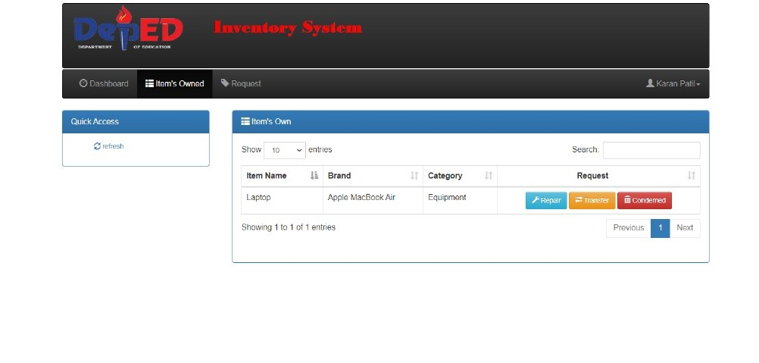
Fig 5.3. Request Information

5.4 DepEd Item Inventory Report:
The expense report shows the date, monthly, yearly report according to our requirement and the analysis is shown in lie graph which describes date and amount of the Item.
.
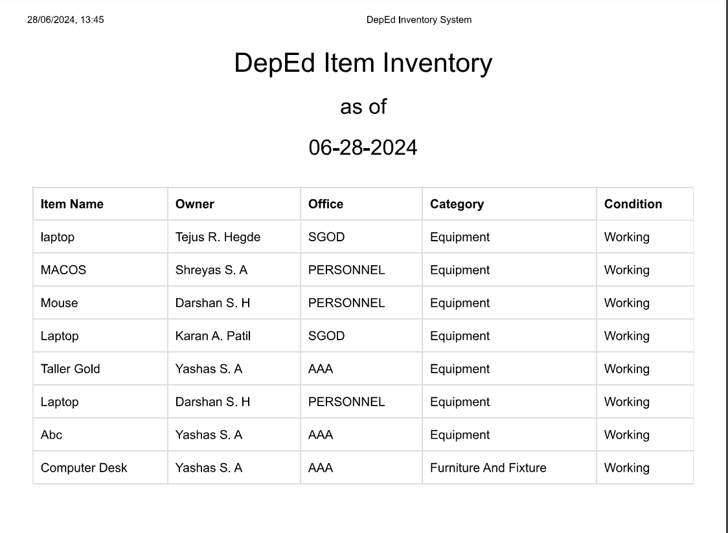

Fig 5.4.DepEd Item Inventory Report

CHAPTER 6

CONCLUSION
The DepEd equipment inventory management system significantly improves the efficiency and transparency of resource management within the Department of Education. By automating inventory tracking and maintenance, it reduces errors, enhances accountability, and ensures accurate record-keeping. The system is scalable to accommodate growing needs and adaptable to new technologies, ensuring long-term sustainability. It also emphasizes data security and regulatory compliance, protecting sensitive information and adhering to best practices. Ultimately, this system supports better educational outcomes by ensuring that schools are well-equipped, fostering an environment conducive to effective teaching and learning. Continuous evaluation and improvement will further enhance its effectiveness.

